**Introducing Python**

**Why Python?**

* It works on multiple different platforms.
* You can write programs with fewer lines of code than other languages.
* Python’s syntax is simple and mimics English, making it beginner friendly.
* Python is used for Web development, Software development, Desktop applications, Database access etc..

**How to Set-up Python in your system?**



There are two versions of

Python

Python 3 is the latest version of the language that is recommended for beginners and most of the users. Python 2 is not updated anymore except for security updates.

You can download and install Python3 in your OS from their official website. [Download Python](https://www.python.org/downloads/)

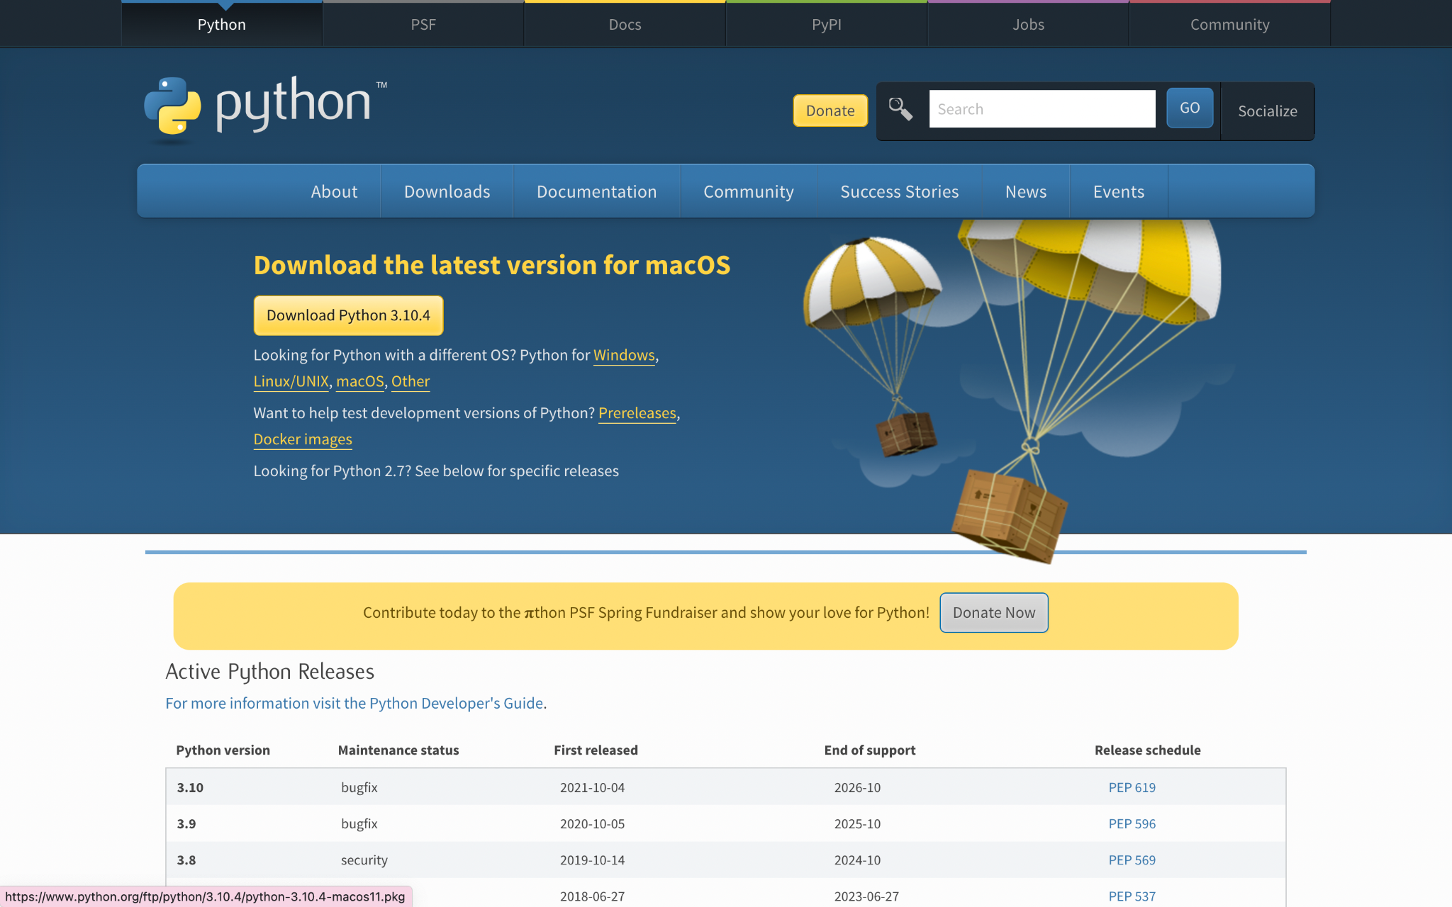

**Editor for Python**

You can write and run simple python programmes from your terminal or command prompt itself. For example,

* Open your Terminal and type “python3” .
* You will be then able to run a few basic programmes in your terminal itself.

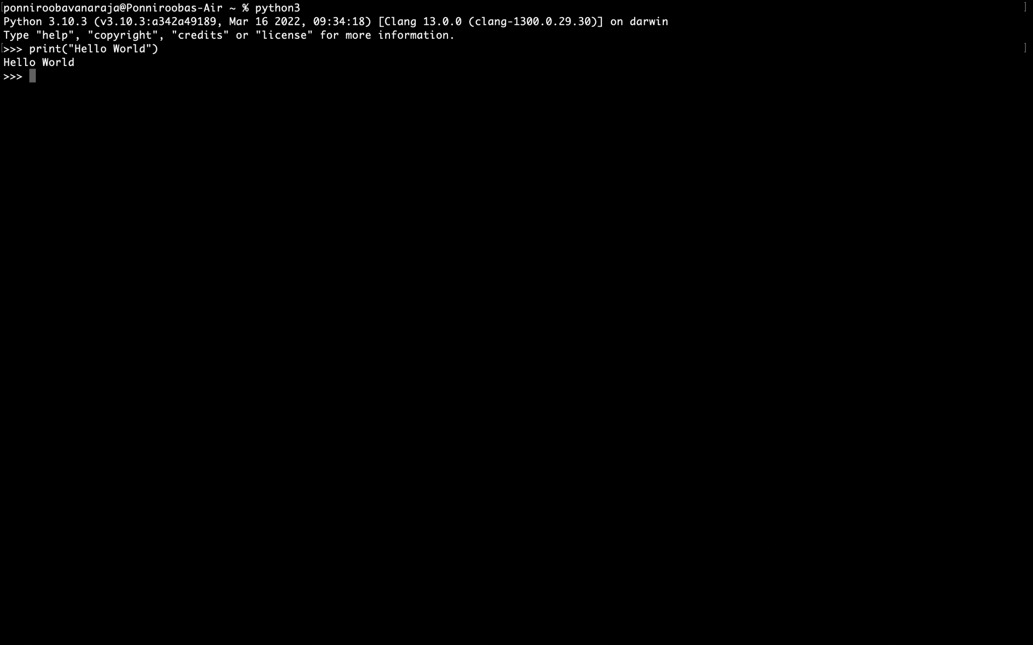

To run python programmes more efficiently, you may need an editor designed just for running python codes. ‘PyCharm’ is a commonly recommended editor for python.

You can install PyCharm here. [PyCharm: the Python IDE for Professional Developers by JetBrains](https://www.jetbrains.com/pycharm/)

You can install PyCharm for free for both intel processors and Apple silicon.

Once Installed, you are ready to develop your first Python project.

